An Analysis of Sexual Dimorphism in the Shape of the Human Proximal Femur and its Relationship to the Acetabulum of the Pelvis.

Cobi Gottschalk

This thesis is submitted in partial fulfilment of the requirements for the degree of MSc Forensic Anthropology, Liverpool John Moores University.

September 2019

Declaration

*I certify that all material in this thesis which is not my own work has been*

*identified.*

*I further declare that this thesis has not already been accepted in substance for any degree, and is not concurrently submitted in candidature for any other degree.*

**Signed** ................................................................*Cobi Gottschalk*

**Date** ................................................................27/08/2019

**Name of candidate**............................................Cobi Gottschalk

Where necessary, students must include a statement below of the nature and extent of the author’s individual contribution if the work is based on joint research:

The author of this dissertation contributed in a number of ways throughout the duration of this study. This included gathering the individual skeletons from the collections provided by Liverpool John Moores University and performing the morphometric measurements necessary for statistical analysis.

**Abstract**

Forensic anthropologists are constantly researching new methods to assist investigators with determining the biological profile of an unknown individual and their skeletal remains. Arguably, one of the most important parts of the biological profile is being able to determine the sex of the victim. A wide variety of methods have been used on the pelvis because of its sexually dimorphic characteristics due to biological influences such as hormonal changes and child bearing in females. However, in cases where the pelvis cannot be used, other bones must be utilized in order to estimate sex. This research focuses primarily on the sexually dimorphic shape differences of the proximal male and female femur and examines the relationship in size between the acetabulum of the pelvis and the femoral head of the femur. These differences in the shape of the femur may reflect the differences observed on the human pelvis. Twenty-five male and twenty-four female adult femora from the Poulton and Gloucester medieval collections at Liverpool John Moores University, containing the proximal end of the femur, were X-rayed using the Kubtec XPERT 80L. The X-rays were downloaded to the software ImageJ and five morphometric features were measured: morphological neck length, biomechanical neck length, trochanter gap, neck shaft angle, and trochanter notch. These numerical values were then analyzed using the program SPSS25 to evaluate the amount of sexual dimorphism between male and female femora. Results from the casewise statistics showed a 69.4 % group accuracy rate and a 71.3 % group accuracy rate when using stepwise statistics. Morphological neck length was found to be the most sexually dimorphic variable of the five measurements. The maximum diameter of twenty-four male and nineteen female adult femora and their corresponding acetabulum, were then measured to determine if there is a correlation between the two features. Results showed that in addition to being sexually dimorphic, there is a high correlation between the size of the acetabulum and the femoral head. Inter-observer and intra-observer error was conducted on five of the specimens measured to test for correlation and showed no significant difference. The results from this study would potentially be beneficial in the identification of unknown human skeletal remains and assisting investigators in situations where there are comingled remains. The results of this study also further adds to the knowledge that the scientific community has on the femur and pelvis.

**Introduction**

In forensic anthropology, determining the biological profile of an unidentified individual’s skeletal remains is of the utmost importance when it comes to forensic casework (Casado, 2017). The main components of this biological profile consists of various characteristics such as age, sex, stature, and ancestry. Determining all or any one of these characteristics can provide investigators with important information pertaining to the background of the individual and perhaps even an insight to the circumstances revolving around their death. Since the beginning of the discipline, forensic anthropologists have been researching, establishing, and utilizing numerous methods to help determine the independent characteristics of the biological profile (Thomas et al., 2016). Some of the methods developed involve using qualitative methods, which rely more on visual characteristics, and quantitative methods, which can be measured numerically. Depending on which features of the skeleton are present, either one method or the other may be used to determine or estimate the age, sex, stature, or ancestry of the remains.

In cases of age estimation, a qualitative technique may be used such as the Suchey-Brooks method in which the pubic symphysis is observed and classified according to its appearance. Another qualitative method that may be used for sex estimation is the narrowness of the greater sciatic notch as mentioned from Walker in Buikstra and Ubelaker’s Standards book (White and Folken, 2005). However, in other instances where such features are not present, it may be more practical to use quantitative measurements, such as taking the maximum diameter of the femoral head. In addition to these three, there are many notable differences in the human skeleton between males and females in regards to sexual dimorphism. The *Os* coxa and sacrum of males are bigger and more robust than in females (White and Folken, 2005). The angle formed between the lower edges of both inferior pubic rami, known as the subpubic angle, is smaller in males than in females and the pelvic inlet is relatively wider in females than in males (White and Folken, 2005). Some of these differences between the male and female skeleton may be attributed to a variety of factors such as hormonal action, in which estrogens and androgens are present throughout various stages of an individual's life, therefore contributing to the development and maintenance of one's bones (Best, 2018). During puberty in males, testosterone has a catalytic effect on their bone structure, while females tend to keep their paedomorphic features (Murton et al., 2015). Another reasoning may be because of mating preferences and sexual selection where members of one biological sex will compete with one another to mate with a member of the opposite sex (Best, 2018). However, one of the most commonly cited factors for sex differences is the functional constraints and biomechanical requirements for childbearing, in that the pelvic region of the female skeleton, needs to adapt in order to give birth (Best, 2018).

The shape and the size of the pelvis can affect the difficulty of labour as well as the delivery of the baby. A narrow pelvis can present more difficulties and obstruction for the baby’s descent through the birth canal as opposed to a broader pelvis, which would allow more room for the baby to squeeze through (Open, 2019). During the third month of pregnancy, the bones and muscles of the baby will begin to grow and by the second trimester, women will start to feel more pressure in the pelvic area due to the weight of the baby (Nierenberg, 2017). The pelvic canal, which is the rough circular space enclosed by the pubic bones in the anterior part of the pelvis and the ischium portion on the posterior side, is the bony passage that the baby must pass through during birth. The baby’s head will first enter the pelvic inlet, which is bigger than the pelvic outlet, and is the portion formed by the round pelvic brim and short ischial spines. The pelvic outlet is the portion of the pelvis formed by the lower border of the pubic bones in front and the lower sacrum near the back. It is the part of the pelvis, in which the baby emerges from the mother’s pelvis (Open, 2019).

While the pelvic differences between males and females in humans may be the most widely used skeletal features for sex estimation, it is important to continue to research other sexually dimorphic bones within the human skeleton. This especially holds true in cases where the pelvis is highly fragmented or in cases in which there is no pelvis available at all for forensic observation. It is important to note that from an anthropological perspective, “sex” and “gender” are two separate entities. Sex refers to the biological characteristics of an individual, whereas gender, is more of a social construct reflecting one’s own social identity. Therefore, these two terms should not be interchanged with one another synonymously (Eliopoulos et al., 2015). Other sexually dimorphic bones such as the human skull or femur can be very useful in helping investigators to estimate sex (Caiaffo et al., 2019). Because the femur articulates proximally with pelvis, it is only natural that there would be sexually dimorphic features found on it between males and females. The femur is the longest bone in the human body and serves the purpose of supporting ones weight, providing a fixture for the muscle to attach, encouraging bipedalic mobility, and storing essential bodily components and elements such as blood cells, phosphate and calcium (Chowdhury et al., 2013). At the proximal end, the femur is formed by the surgical neck that connects the shaft of the bone to the proximal epiphysis and the anatomical neck, which unites the head to the lesser and greater trochanters (Mourão & Vasconcellos, 2001). It articulates proximally with the acetabulum of the pelvis and extends down to the knee forming the skeleton portion of the body that makes up the thigh (Caiaffo et al., 2019). There have been many studies done on the sexual dimorphism of the femur and some researchers believe that it is just as a reliable indicator for sex estimation than the sexually dimorphic features of the skull. In some instances, there has even been cases in which using the femur has provided a better accuracy rate for sex estimation than using features from the human skull (Srivastava, 2012). In addition, due to the robusticity and strength of the femur, it is less susceptible to harsh environmental conditions, which can allow for it to often be recovered completely intact (Srivastava, 2012).

Many of the studies that have been done on the femur, focus on determining sex using morphometric measurements. One study in particular looked at six different morphometric measurements of the proximal femur and sought to determine whether there were any differences in the femoral morphologies between males and females (Caiaffo et al., 2019). These measurements consisted of the femoral head and neck diameter lying along the craniocaudal axis, the diameter of neck and femoral head on the sagittal axis, the intertrochanteric line length, and the length of the femoral neck (Caiaffo et al., 2019). Their sample size included one hundred and twenty intact femora, with no signs of trauma, from the Anatomy Sector of the Department of Animal Morphology and Physiology of the Federal Rural University of Pernambuco. Fifty-eight of the specimens consisted of male cadavers and the other sixty-two were female cadavers. Researchers found that for nearly every single one of the measurements taken on the proximal femora, there were signs of sexual dimorphism and that the measurements obtained from the male cadaver femora were consistently larger than that of the female cadaver femora. The only variable that showed no signs of significant difference between males and females was the length of the femoral neck.

It is important to keep in mind that human skeletal features can vary from one population to another, so no single standardized formula can be applied for sex estimation (Alunni-Perret et al., 2008). Therefore, the results of another study that focused specifically on developing osteometric standards for a North Indian population, further supports existing literature that there are sexually dimorphic features of the proximal femur. The results of their research, in which they measured eight morphometric features on each one of the one hundred and twenty-two femora, showed that there was a prediction accuracy rate ranging from between 70.5 % and 83.6 %. The measurements taken were the maximum length, proximal breadth, epicondylar breadth, vertical and transverse diameter of the head, the vertical diameter of the neck, the antero-posterior diameter of the lateral condyle, and the antero-posterior diameter of the medial condyle. The sample consisted of ninety-four males and twenty-eight females from the Department of Forensic Medicine at Banaras Hindu University (Caiaffo et al., 2019).

According to the results of these studies, there is enough substantial evidence to continue to research the sexual dimorphism of the femur, particularly the proximal end. A study done in 2002 on the *Australopithecus afarensis* Maka Femur MAK-VP-1/1, showed that the species had a remarkably similar hip joint to that of the modern human and is the oldest known skeletal evidence for locomotion in the *Australopithecus afarensis* species (Lovejoy et al., 2002). In the research, several different measurements were used to examine dimensional shape differences of the proximal femur between humans and African apes. These measurements were intended to reflect the spatial differences of the hip joint in quadrupeds and bipeds (Lovejoy et al., 2002). Among those employed included the biomechanical neck length, the depth of the trochanteric notch, morphological neck length, trochanteric gap, and the collo-diaphyseal angle (Lovejoy et al., 2002). While these variables were used to examine the shape differences between humans and African Apes, it is likely that the same measurements would be able to determine sexual dimorphic shape differences between male and females in human populations. These differences should as well reflect the sexual dimorphic differences of the pelvis. Therefore, the purpose of this research is primarily to determine whether the measurements used in the Maka Femur study can be used for sex estimation in humans. Furthermore, it seeks to determine if there is a correlation in size between the femoral head and acetabulum.

If using these measurements on the proximal femur can allow for forensic anthropologists to estimate sex, then it provides investigators with another tool in figuring out an important part of the biological profile. Furthermore, it would provide researchers studying the proximal femur with more information on the topic. As seen in the results from the two studies looking at the femora of human cadavers and of a North Indian population, there is a strong indication for sexual dimorphism in the proximal end of the femur. Therefore, applying the measurements used in the Maka Femur study, specifically to males and females within human populations, may further add to the evidence and strengthen the basis of using the proximal femur as a reliable method for sex estimation.

Also, being able to determine whether there is a relationship between the size of the acetabulum and the size of the femoral head would be beneficial to not only forensic anthropologists for sex estimation, but also for individual identification in situations where there is commingling of skeletal remains. Commingled remains may be encountered in any number of events, but particularly where there have been cases of mass fatalities or disasters (Adams and Byrd, 2014). Commingled remains is known as the intermixing of human remains from more than one individual. As one would expect, when there is an increase in the number of commingled individuals, allocating the remains to the correct individual becomes exceptionally more difficult. This especially holds true when the remains are highly fragmented and only certain features of bones are present. This has the potential to lead to certain problems when it comes to the personal identification and returning the skeletal remains to the individual’s next of kin (Adams and Byrd, 2014). Therefore, if there is a correlation between the acetabulum and the femoral head, it would be useful in narrowing down the possible proximal femora, to the corresponding acetabulum of the pelvis, and then matching them to the correct individual.

As noted earlier, populations can vary from one region to another so it is necessary to establish specific standards for different regions (Timonov et al., 2014). It is therefore important to discuss the background of the sites from which the skeletal collections used in this research come from. Located five miles south outside of Chester, there is an English county of Gloucestershire called Poulton. Currently, there are ongoing archaeological excavations here due to the extensive amount of evidence found within the area for human activity, some of which dates back to ten thousand years ago (Poulton Research Project, 2019). A vast number of the deposits here consist of Roman ditches, a medieval chapel, industrial structures, and so on. The site, which sits on a low plateau, contains glacial deposits as part of the landscape’s natural soil (Jordan, 2019). The discovery of the site occurred when looking for the Cistercian Abbey, decades before excavations began in 1995 (Emery, 2002). Since the time of its discovery, remnants of a chapel have been uncovered along with over eight hundred burials, which have been excavated. Before the archaeological excavation of this site, the area had been cereal cultivated for agricultural purposes over a long period of time. Therefore, the upper twenty-five to thirty centimeters of the landscape profile has been subjected to repeated ploughing making it an Ap horizon classification (Jordan, 2019).

Gloucester, like Poulton, is another district of Gloucestershire located in the South West of England that has produced numerous archaeological finds dating back to the ancient Roman period. The first settlement here took place as a strategic location for a military fortress somewhere around the time of forty to fifty AD. In 97 AD, under the rule of emperor Nerva, Gloucester was given the title Colonia Nervia Glevensis, which in the Roman Empire, was the highest status a provincial town could receive (Visitgloucester.co.uk, 2019). It would eventually be granted its first charter by King Henry the second in 1155 (Spry, 2009). During the Medieval period, Gloucester, among two others, was one of the most important cities in England becoming an annual meeting ground for the king and the Great Council (Visitgloucester.co.uk, 2019). Some of the archaeological work that has been done here in the past thirty years began in 1988 with the excavation of three tenements containing stone built houses (Atkin and Garrod, 1989). Upon excavation, there was an increasing density in the amount of burials being recovered from St. Owens cemetery. From the churchyard, along with other burials from the Royal Infirmary and Independent Chapel, there were over three hundred medieval burials (Atkin and Garrod, 1989).

**Methods**

**Femoral Shape**

Twenty-five female and twenty-four male femora containing the proximal end were gathered from the Gloucester and Poulton collection at Liverpool John Moores University for data analysis. The specimens were in relatively good condition with little to no signs of skeletal trauma. The left femur was used from all individuals whenever possible as a means of maintaining consistency. In cases where there was no left femur, the right femur would be used as a substitute. These specimens were placed individually, one at a time, into a Kubtec Xpert 80L X-ray machine. The X-ray machine proceeded through a thirty-minute warm up procedure and was then calibrated for X-ray analysis. Each femur was placed onto its posterior side inside of the Kubtec Xpert 80L in order to obtain an image of the anterior surface, displaying morphometric features used to distinguish shape, such as the biomechanical neck length, the trochanteric gap, the notch depth, the morphological neck length, and the neck-shaft angle. These measurements are defined as so (Lovejoy et al., 2002):

1. *Biomechanical neck length*- Length of the tangent line to the femoral heads superior surface and perpendicular to the line in which is not only tangent to the lateral most projection of the greater trochanter but also parallel to the femoral shafts centroidal axis.
2. *Morphological neck length*- Length of the line that is taken along the femoral neck and head’s centroidal axis and that bisects them from its juncture with the shaft of the femora’s centroidal axis and its intersection with the head’s articular surface.
3. *Depth of trochanteric notch*- The distance from the line of the biomechanical neck length to the deepest part of the trochanteric notch.
4. *Trochanteric gap*- The minimum distance from the greater trochanter’s most superior point to the line of the biomechanical neck length. It is worth noting that the smaller this distance is, the greater the height of the greater trochanter in relativity to the femoral head.
5. *Collo-diaphyseal angle (neck shaft angle)*- The angle of the point between the centroidal axes of the head and neck to that of the shaft.

**Figure 1. Metrics described to distinguish shape differences (Lovejoy et al., 2002).**

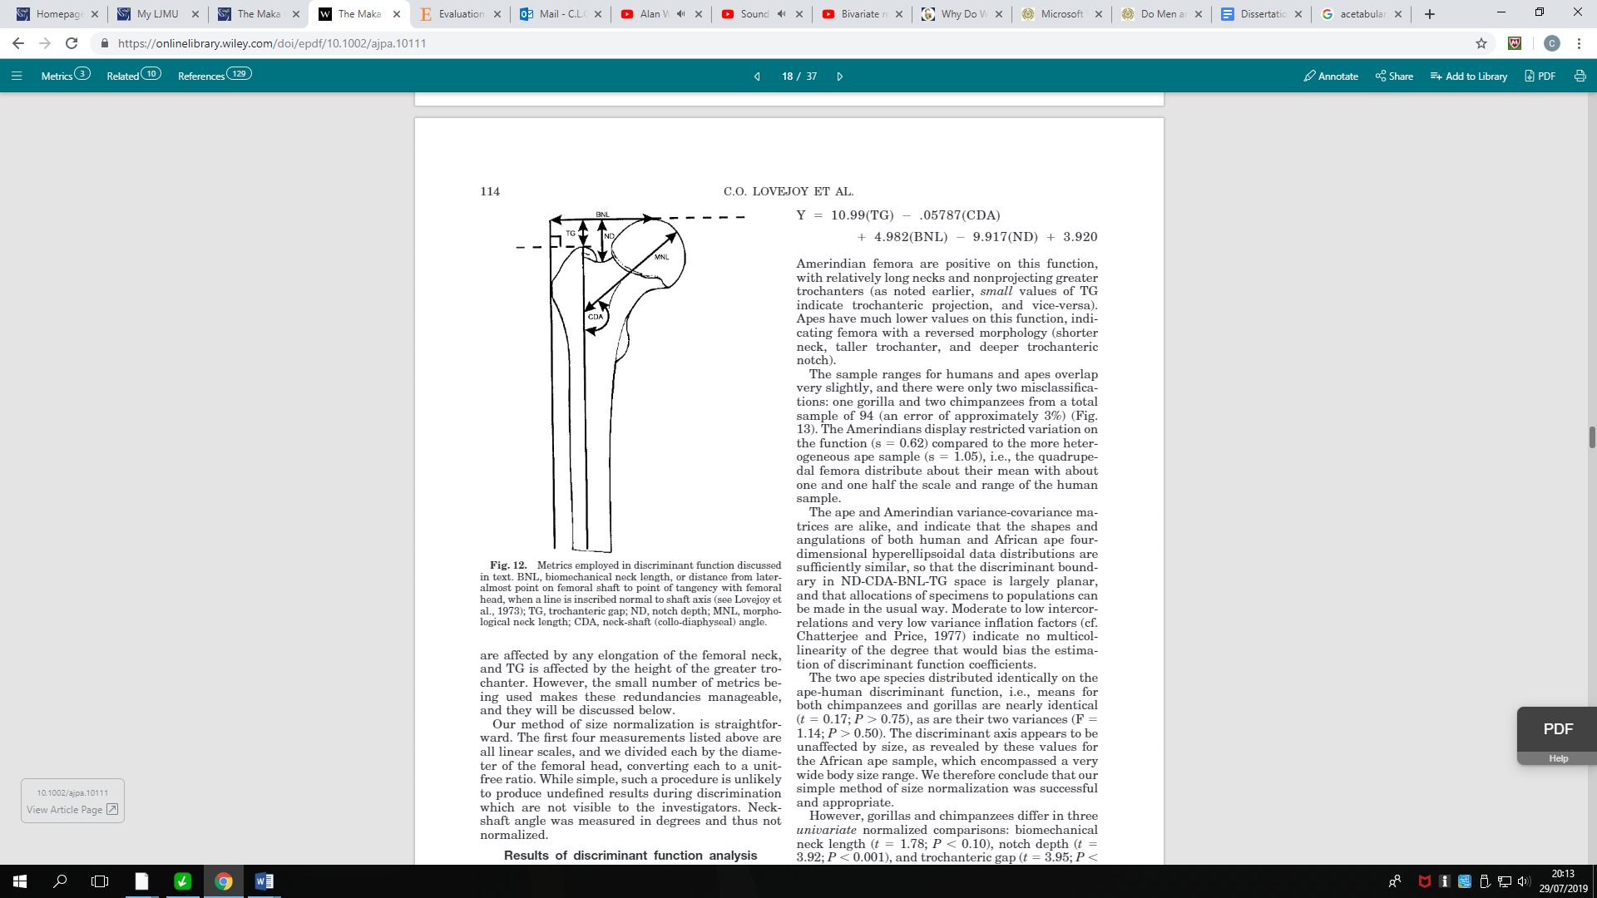

**TG= Trochanter Gap; ND= Notch Depth; CDA= Neck Shaft Angle; BNL= Biomechanical Neck Length; MNL= Morphological Neck Length.**

A four centimeter measuring tape was placed inside of the machine next to the femur in order to provide a point of reference when setting the scale later in the software ImageJ. The femur was then photographed using the Kubtec’s standard settings to see the specimen in its original form. Once photographed, an X-ray was taken to capture the finer dimensions of the bone. The X-ray was pre-set to its original settings, therefore the contrast of the image was increased to obtain a clearer outline of the femur. After all of the X-rays were taken, the images were put onto a hard drive and transferred over to the computer software program ImageJ. In order to begin measuring the femora, each image first needed to be set to scale. This was done using the line tool, which was drawn across the measuring piece of the X-ray image. The scale was set at four centimeters, which was the length of the measuring piece. The ROI Manager was opened up in order to keep the lines from disappearing from the image. After each line was placed on the image, it was added to the ROI Manager. Measurements were taken from the biomechanical neck, the morphological neck, the notch depth, the trochanteric gap, and the angle of the neck shaft.

**Figure 2. Measurements being taken from Gloucester Skeleton 0133 on software ImageJ.**

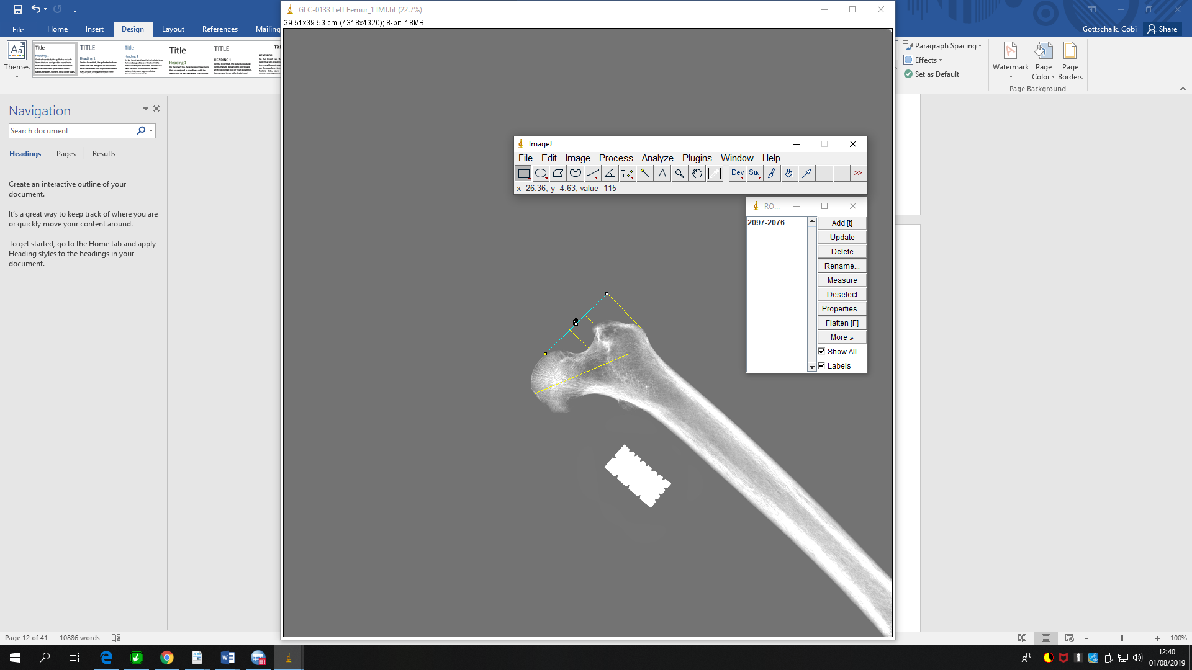

Once the metric measurements of every specimen was recorded, statistical analysis was run using SPSS25. Each feature measured on the femora were given independent variables and then were matched to the respective sex and specimen from which the measurements came from. Sex was assigned values, one being classified as male and two being classified as female. Discriminant function analysis was ran using Fisher’s coefficients. Both casewise and stepwise analysis were ran.

**Femoral head and Acetabulum**

Twenty-four males and nineteen females from the Gloucester and Poulton collection at Liverpool John Moores University, containing both a proximal femoral head and complete acetabulum were used to examine whether or not there is a correlation between the two features. A Yakamoz 6 inch/ 150 mm LCD Digital Caliper Electronic Vernier Micrometer Measuring Tool was used to measure the maximum diameter of the femoral head and the acetabulum. The measurements are defined as so:

1. *Maximum diameter of the femoral head*- The maximum point in which the diameter of the femoral head is greatest.
2. *Maximum diameter of the acetabulum*- The maximum point in which the diameter of the acetabulum is greatest.

Measurements for the maximum diameter of the acetabulum were taken by first placing one end of the outside lower jaw on the ischium portion of the acetabulum, and then rotating the other outside jaw around the rim of the acetabulum where the inner walls align with the edge of the jaws. Then, while simultaneously rotating the jaws around the acetabulum, the numerical values on the LCD display were looked at to see where the number in millimeters was greatest. Once the maximum point of the diameter for the acetabulum was found, it was recorded and the same process was done on the corresponding femoral head. Measurements of the femoral head were taken by placing the outside lower jaws around the head of the femur and then rotating the digital caliper around it until a maximum point was found. Once this was completed, SPSS 25 was used again to run a discriminant function analysis, produce a simple scatter dot line, and to check for the correlation between the two features. Two equations were than produced through running linear regression swapping one feature for the other as the dependent and independent variable.

**Figure 3. Measuring the maximum diameter for the acetabulum with digital caliper.**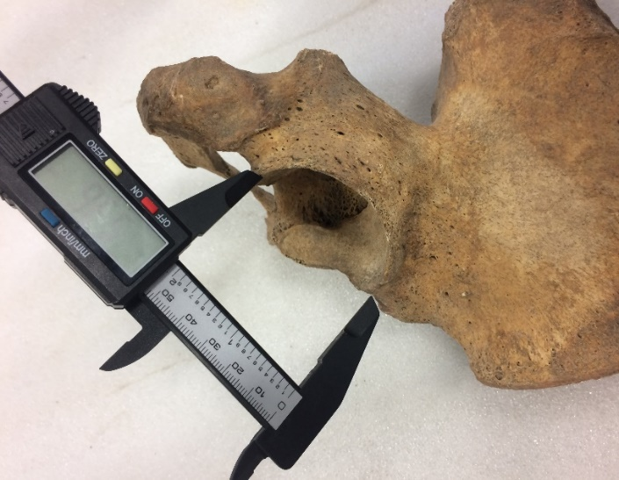

Inter-observer and intra-observer was done in order to check for reproducibility of the methods used in this research. Three participants were asked to measure the maximum diameter of both the femoral head and acetabulum. These measurements were done on five male specimens used from the Poulton collection, making for a total of ten measurements performed by each participant. These particular skeletons were picked randomly and were used for no other reason than to check for the error between participants. For intra-observer, the same measurements were conducted by myself two weeks after the initial measurements were taken. These were performed on the same individuals used for the inter-observer analysis. Once all of the measurements had been completed by participants one, two, and three, the data was placed into SPSS 25, along with my own measurements for intra-observer, and a one-way anova was carried out.

**Results**

Discriminant function analysis was applied to the measurements obtained from the sample collections, which included measurements of the acetabulum and proximal femur. The primary role of using discriminant function analysis is to find the nature of differences and as to how the linear combination structure discriminates multivariate profiles (Fisher, 1936). It is used when there are qualitative independent variables and categorical dependent variables (Ohman, 2018). Within the discriminant function analysis, two types of statistics were employed known as casewise and stepwise statistics to determine the most sexually dimorphic morphometric feature(s).

**Femoral Shape**

***Casewise Statistics***:

One Eigenvalue was extracted (Table 2), which explained 100 % of the variance. The larger the Eigen value, the more variance the function explains in the dependent variable and outcome variable. The canonical correlation is 0.417.

**Table 1. The Eigenvalues of the Discriminant Function.**

|  |  |  |  |  |
| --- | --- | --- | --- | --- |
| **Eigenvalues** | | | | |
| Function | Eigenvalue | % of Variance | Cumulative % | Canonical Correlation |
| 1 | .211a | 100.0 | 100.0 | .417 |
| a. First 1 canonical discriminant functions were used in the analysis. | | | | |

The structure matrix (Table 2), which reflect the standardized canonical discriminant function coefficients, shows that morphological neck length was the strongest discriminant out of the five independent variables at 0.919, followed by biomechanical neck length at 0.708, then neck notch depth at 0.500. Trochanter gap and neck shaft angle were less discriminatory than the other three receiving scores of only 0.288 and 0.094. Thus, the most discriminatory parameters both are related to the length of the femoral neck.

**Table 2. Structure matrix of the independent variables showing the strength of each for the Discriminant Function.**

|  |  |
| --- | --- |
| **Structure Matrix** | |
|  | Function |
| 1 |
| Morphological Neck Length | .919 |
| Biomechanical Neck Length | .708 |
| Neck Notch Depth | .500 |
| Trochanter Gap | .288 |
| Neck Shaft Angle | .094 |
| Pooled within-groups correlations between discriminating variables and standardized canonical discriminant functions  Variables ordered by absolute size of correlation within function. | |

The results of the function of the group centroids show the mean scores for the discriminate function. This allows for the determination of how scores of discriminant function one, relate to group membership. Table 3 shows that males had a mean of 0.459 and a - 0.440 for females. The difference between the means for males and females show that there is a clear discriminatory factor in distinguishing between the two sexes.

**Table 3. The mean values for differences between males and females for functions at group centroids.**

|  |  |
| --- | --- |
| **Functions at Group Centroids** | |
| Sex | Function |
| 1 |
| Male | .459 |
| Female | -.440 |
| Unstandardized canonical discriminant functions evaluated at group means | |

Figure 5 shows the distribution of male and female femora along the first discriminant function (DF1). For the twenty-four male specimens, the mean score is 0.46 and the standard deviation is 1.102. For the twenty-five female specimens, the mean score is 0.44 and the standard deviation is 0.891. The Y-axis shows the frequency in which the height of the bar indicates how many values there were for the discriminant function score.

**Figure 4. Histogram of Discriminant Scores from Function 1 for both males and females.**

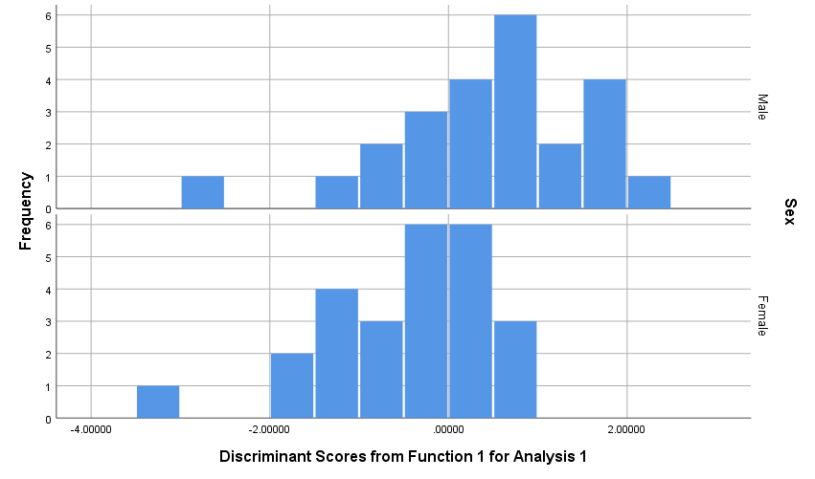

The results for femoral shape when using case wise statistics showed that there was an overall accuracy rate of 69.4 percent when using the independent variables of neck notch depth, biomechanical neck length, morphological neck length, trochanter gap, and neck-shaft (collo-diaphyseal) angle. Table 4 shows that seventeen of the twenty-four male specimens were correctly classified as male (70.8 %) and seventeen of the twenty-five female specimens were correctly classified as female (69.4 %).

**Table 4. Classification results for Discriminant Function Analysis using case wise statistics.**

|  |  |  |  |  |  |
| --- | --- | --- | --- | --- | --- |
| **Classification Resultsa** | | | | | |
|  |  | Sex | Predicted Group Membership | | Total |
|  |  | Male | Female |
| Original | Count | Male | 17 | 7 | 24 |
| Female | 8 | 17 | 25 |
| % | Male | 70.8 | 29.2 | 100.0 |
| Female | 32.0 | 68.0 | 100.0 |
| a. 69.4% of original grouped cases correctly classified. | | | | | |

***Stepwise Statistics***:

Using stepwise analysis, one Eigenvalue was extracted, which explained 100 % of the total variance. The canonical correlation is 0.389.

**Table 5. Eigenvalue using stepwise analysis.**

|  |  |  |  |  |
| --- | --- | --- | --- | --- |
| **Eigenvalues** | | | | |
| Function | Eigenvalue | % of Variance | Cumulative % | Canonical Correlation |
| 1 | .178a | 100.0 | 100.0 | .389 |
| a. First 1 canonical discriminant functions were used in the analysis. | | | | |

Stepwise analysis results of the Structure Matrix showed that morphological neck length and biomechanical neck length, but especially morphological neck length, was significantly stronger in discriminating for sex than the all the other independent variables. Morphological neck length was scored 1.000 and there was a 0.761 for biomechanical neck length. Neck notch depth (0.186), trochanter gap (0.137), and neck shaft angle (0.012) all came in at 0.186 and below.

**Table 6. Structure Matrix using stepwise analysis.**

|  |  |
| --- | --- |
| **Structure Matrix** | |
|  | Function |
| 1 |
| Morphological Neck Length | 1.000 |
| Biomechanical Neck Lengtha | .761 |
| Neck Notch Deptha | .186 |
| Trochanter Gapa | .137 |
| Neck Shaft Anglea | .012 |
| Pooled within-groups correlations between discriminating variables and standardized canonical discriminant functions  Variables ordered by absolute size of correlation within function. | |
| a. This variable not used in the analysis. | |

Using stepwise analysis, the mean for males and females from the Functions at Group Centroids came out to 0.422 (males) and - 0.405 (females). This difference in means again shows that there are sexually dimorphic differences between males and females.

**Table 7. Functions at Groups Centroids under Stepwise Analysis.**

|  |  |
| --- | --- |
| **Functions at Group Centroids** | |
| Sex | Function |
| 1 |
| Male | .422 |
| Female | -.405 |
| Unstandardized canonical discriminant functions evaluated at group means | |

Figure 6 shows the canonical discriminant function for both males and females under stepwise statistics. For the twenty-four male specimens, the mean score is 0.42 and the standard deviation is 1.084. For the twenty-five female specimens, the mean score is 0.40 and the standard deviation is 0.912.

**Figure 5. Histogram of Discriminant Scores from function 1 for both males and females using Stepwise Statistics.**

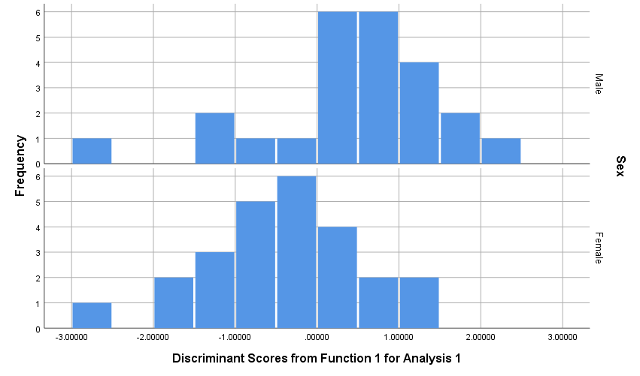

When running stepwise analysis, the classification results showed that eighteen males and seventeen females were predicted correctly. For males, there was a 75 % accuracy rate and a 68 % accuracy for predicting females.

**Table 8. Classification results using stepwise analysis.**

|  |  |  |  |  |  |
| --- | --- | --- | --- | --- | --- |
| **Classification Resultsa** | | | | | |
|  |  | Sex | Predicted Group Membership | | Total |
|  |  | Male | Female |
| Original | Count | Male | 18 | 6 | 24 |
| Female | 8 | 17 | 25 |
| % | Male | 75.0 | 25.0 | 100.0 |
| Female | 32.0 | 68.0 | 100.0 |
| a. 71.4% of original grouped cases correctly classified. | | | | | |

***Correlations:***

The correlation between morphological neck length and biomechanical neck length is relatively high at 0.787 and significant (P < 0.001).

**Table 9. Correlations chart for Biomechanical and Morphological Neck Length.**

|  |  |  |  |
| --- | --- | --- | --- |
| **Correlations** | | | |
|  | | Biomechanical Neck Length | Morphological Neck Length |
| Biomechanical Neck Length | Pearson Correlation | 1 | .787** |
| Sig. (2-tailed) |  | .000 |
| N | 49 | 49 |
| Morphological Neck Length | Pearson Correlation | .787** | 1 |
| Sig. (2-tailed) | .000 |  |
| N | 49 | 49 |
| **. Correlation is significant at the 0.01 level (2-tailed). | | | |

**Femoral head and Acetabulum**

Results for femoral head and acetabular rim correlation indicates to be true. The simple scatter graph in figure 7 shows that there is a high correlation between the maximum diameter of the acetabulum and the femoral head and that they are sexually dimorphic. The slope of the R-squared line is close to one being at 0.874, which signifies a strong relationship between the two features and categorical sexing respectively. R squared measurements are used to indicate the degree of variation in a dependent variable which is explained through the independent variables in a regression model (Investopedia, 2019).

**Figure 6. Simple scatter graph showing a high correlation between the femur and acetabulum.**

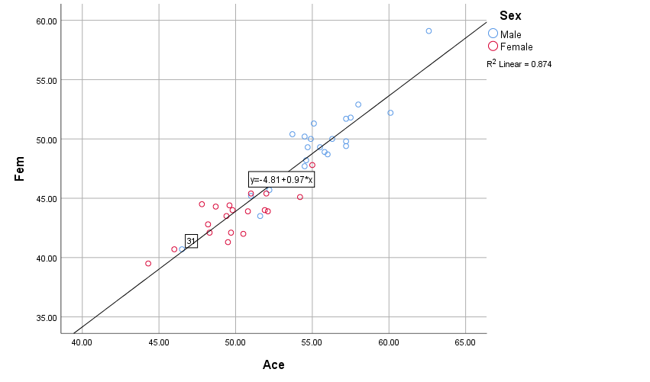

This correlation between the two features is further shown in the correlations results in Table 10. The maximum diameter of the femoral head and the acetabulum have a 0.935** correlation that is significant at the 0.01 level (2-tailed). The correlation matrix shows the correlation coefficients between the two sets of variables used.

**Table 10. Correlations results using Pearson bivariate correlation coefficients that indicate a strong correlation between the two features.**

|  |  |  |  |
| --- | --- | --- | --- |
| **Correlations** | | | |
|  | | Ace | Fem |
| Ace | Pearson Correlation | 1 | .935** |
| Sig. (2-tailed) |  | .000 |
| N | 43 | 43 |
| Fem | Pearson Correlation | .935** | 1 |
| Sig. (2-tailed) | .000 |  |
| N | 43 | 43 |
| **. Correlation is significant at the 0.01 level (2-tailed). | | | |

The ANOVA from the linear regression analysis when using the acetabulum as a dependent variable is shown in table 11. The significance value is 0.000^b, which is less than alpha 0.05, therefore, it is a significant model. F(1, 41) = 283.164, p = 0.000.

**Table 11. ANOVA of linear regression using the acetabulum as a dependent variable.**

|  |  |  |  |  |  |  |
| --- | --- | --- | --- | --- | --- | --- |
| **ANOVAa** | | | | | | |
| Model | | Sum of Squares | df | Mean Square | F | Sig. |
| 1 | Regression | 558.594 | 1 | 558.594 | 283.164 | .000b |
| Residual | 80.880 | 41 | 1.973 |  |  |
| Total | 639.474 | 42 |  |  |  |
| a. Dependent Variable: Ace | | | | | | |
| b. Predictors: (Constant), Fem | | | | | | |

The model summary shows the percentage of variance within the dependant variable (acetabulum) that is explained by the independent variable (femoral head). The adjusted R squared, when multiplied by 100, shows 87 % of variance.

**Table 12. Model summary showing percentage of variance when using the acetabulum as a dependent variable.**

|  |  |  |  |  |
| --- | --- | --- | --- | --- |
| **Model Summary** | | | | |
| Model | R | R Square | Adjusted R Square | Std. Error of the Estimate |
| 1 | .935a | .874 | .870 | 1.40452 |
| a. Predictors: (Constant), Fem | | | | |

The coefficients table provides the equation for predicting the size of the femoral head when using the acetabulum as the dependent variable. The equation is the (maximum diameter of femoral head) X (0.897) + 10.991 = (maximum diameter of acetabulum). There is a 95.0 % Confidence Interval for B within the Lower Bound and the Upper Bound levels.

**Table 13. Equation for when using the acetabulum as a dependent variable to predict the size of the acetabulum.**

|  |  |  |  |  |  |  |  |  |
| --- | --- | --- | --- | --- | --- | --- | --- | --- |
| **Coefficientsa** | | | | | | | | |
| Model | | Unstandardized Coefficients | | Standardized Coefficients | t | Sig. | 95.0% Confidence Interval for B | |
| B | Std. Error | Beta | Lower Bound | Upper Bound |
| 1 | (Constant) | 10.991 | 2.496 |  | 4.404 | .000 | 5.951 | 16.032 |
| Fem | .897 | .053 | .935 | 16.827 | .000 | .789 | 1.004 |
| a. Dependent Variable: Ace | | | | | | | | |

Linear regression graph with the acetabulum as the dependent variable.

**Figure 7. Bivariate Scatter plot showing the strong correlation between the acetabulum and femoral head.**

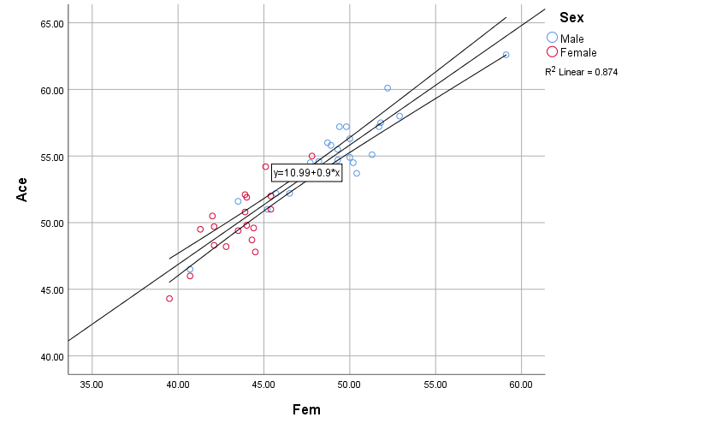

The ANOVA from the linear regression analysis when using the femoral head as a dependent variable is shown in table 6. The significance value is 0.000^b, which is less than alpha 0.05, therefore, it is a significant model. F(1, 41) = 283.164, p = 0.000.

**Table 14. ANOVA of linear regression using the femoral head as a dependent variable.**

|  |  |  |  |  |  |  |
| --- | --- | --- | --- | --- | --- | --- |
| **ANOVAa** | | | | | | |
| Model | | Sum of Squares | df | Mean Square | F | Sig. |
| 1 | Regression | 606.700 | 1 | 606.700 | 283.164 | .000b |
| Residual | 87.846 | 41 | 2.143 |  |  |
| Total | 694.546 | 42 |  |  |  |
| a. Dependent Variable: Fem | | | | | | |
| b. Predictors: (Constant), Ace | | | | | | |

The model summary shows the percentage of variance within the dependant variable (femoral head) that is explained by the independent variable (acetabulum). The adjusted R squared, when multiplied by 100, shows 87 % of variance.

**Table 15. Model summary showing percentage of variance when using the femoral head as a dependent variable.**

|  |  |  |  |  |
| --- | --- | --- | --- | --- |
| **Model Summary** | | | | |
| Model | R | R Square | Adjusted R Square | Std. Error of the Estimate |
| 1 | .935a | .874 | .870 | 1.46375 |
| a. Predictors: (Constant), Ace | | | | |

The coefficients table provides the equation for predicting the size of the femoral head when using the acetabulum as the dependent variable. The equation is the (Maximum diameter of acetabulum) X (0.974) – 4.805 = (Maximum diameter of femoral head). There is a 95.0 % Confidence Interval for B within the Lower Bound and the Upper Bound levels.

**Table 16. Equation for when using the femoral head as a dependent variable to predict the size of the femoral head.**

|  |  |  |  |  |  |  |  |  |  |
| --- | --- | --- | --- | --- | --- | --- | --- | --- | --- |
| **Coefficientsa** | | | | | | | | | |
| Model | | Unstandardized Coefficients | | Standardized Coefficients | t | Sig. | 95.0% Confidence Interval for B | |
| B | Std. Error | Beta | Lower Bound | Upper Bound |
| 1 | (Constant) | -4.805 | 3.066 |  | -1.567 | .125 | -10.998 | 1.387 |
| Ace | .974 | .058 | .935 | 16.827 | .000 | .857 | 1.091 |
| a. Dependent Variable: Fem | | | | | | | | | |

A linear regression graph femoral head as the dependent variable.

**Figure 8. Bivariate Scatter plot showing the correlation between the femoral head and acetabulum.**

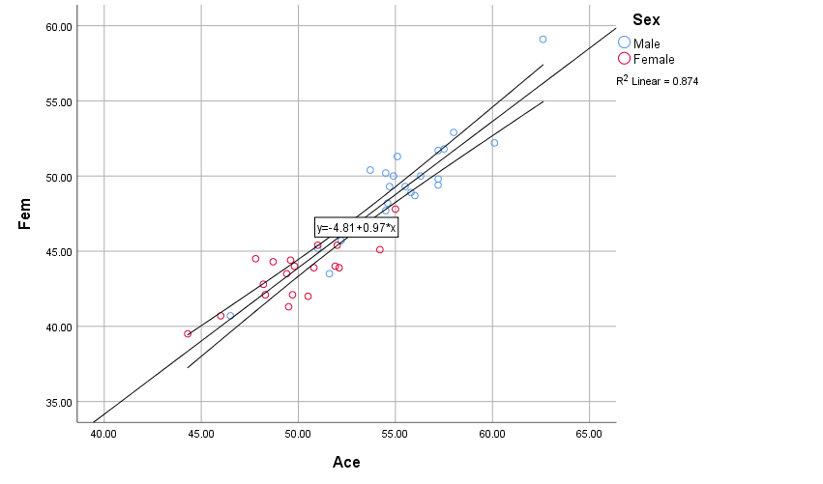

When running DFA for both the acetabulum and femoral head together, classification results showed that there was an 88.4 % accuracy rate for predicting sex. Out of the twenty-four male specimens, twenty were correctly predicted as males for an accuracy of 83.3 %. For the nineteen female specimens, eighteen were correctly classified as female and had an accuracy rate of 94.7 %.

**Figure 17. Classification results for both the acetabulum and femoral head.**

|  |  |  |  |  |  |
| --- | --- | --- | --- | --- | --- |
| **Classification Resultsa** | | | | | |
|  |  | Sex | Predicted Group Membership | | Total |
|  |  | Male | Female |
| Original | Count | Male | 20 | 4 | 24 |
| Female | 1 | 18 | 19 |
| % | Male | 83.3 | 16.7 | 100.0 |
| Female | 5.3 | 94.7 | 100.0 |
| a. 88.4% of original grouped cases correctly classified. | | | | | |

The structure matrix for this analysis showed that the femoral head is a stronger discriminator for sex than the acetabulum. The femoral head scored a 0.995 and the acetabulum was slightly lower with a score of 0.921.

**Figure 18. Structure matrix for DFA ran on the femoral head and the acetabulum.**

|  |  |
| --- | --- |
| **Structure Matrix** | |
|  | Function |
| 1 |
| Fem | .995 |
| Ace | .921 |
| Pooled within-groups correlations between discriminating variables and standardized canonical discriminant functions  Variables ordered by absolute size of correlation within function. | |

DFA was also run separately for the femoral head and acetabulum. When just using the femoral head, results show that 88.4 % of the specimens were classified correctly. Twenty of the twenty-four males were predicted as males and eighteen of the nineteen females were predicted as females. Females had a higher accuracy rate than males at 94.7 % whereas males were 83.3 %.

**Figure 19. Classification results for DFA using maximum diameter of femoral head.**

|  |  |  |  |  |  |
| --- | --- | --- | --- | --- | --- |
| **Classification Resultsa** | | | | | |
|  |  | Sex | Predicted Group Membership | | Total |
|  |  | Male | Female |
| Original | Count | Male | 20 | 4 | 24 |
| Female | 1 | 18 | 19 |
| % | Male | 83.3 | 16.7 | 100.0 |
| Female | 5.3 | 94.7 | 100.0 |
| a. 88.4% of original grouped cases correctly classified. | | | | | |

When using just the acetabulum, classification results showed that 83.7% of the specimens were classified correctly. Nineteen of the twenty-four males were predicted as males and seventeen of the nineteen females were predicted as females. Males had a lower accuracy rate than females at 79.2 % whereas females had an 89.5 % accuracy rate.

**Figure 20. Classification results for DFA using maximum diameter of the acetabulum.**

|  |  |  |  |  |  |
| --- | --- | --- | --- | --- | --- |
| **Classification Resultsa** | | | | | |
|  |  | Sex | Predicted Group Membership | | Total |
|  |  | Male | Female |
| Original | Count | Male | 19 | 5 | 24 |
| Female | 2 | 17 | 19 |
| % | Male | 79.2 | 20.8 | 100.0 |
| Female | 10.5 | 89.5 | 100.0 |
| a. 83.7% of original grouped cases correctly classified. | | | | | |

**Inter/Intra-Observer:**

The results from the inter-observer and intra-observer ANOVA test show that there was no significant difference in the methodology used for measurements taken on the acetabulum and femur between participants. The significance between groups for femoral head measurements was 0.694 and 0.952 for the acetabulum.

**Figure 21. Anova statistical analysis for Inter-observer and Intra-observer for femoral head and acetabular rim measurements.**

|  |  |  |  |  |  |  |
| --- | --- | --- | --- | --- | --- | --- |
| **ANOVA** | | | | | | |
|  | | Sum of Squares | df | Mean Square | F | Sig. |
| Femur | Between Groups | 15.412 | 4 | 3.853 | .560 | .694 |
| Within Groups | 137.668 | 20 | 6.883 |  |  |
| Total | 153.080 | 24 |  |  |  |
| Acetabulum | Between Groups | 2.192 | 4 | .548 | .169 | .952 |
| Within Groups | 64.748 | 20 | 3.237 |  |  |
| Total | 66.940 | 24 |  |  |  |

**Discussion**

**Femoral Shape**

The results from the study show that there is sexual dimorphism in mainly the size as opposed to shape of the proximal femur between males and females. When using casewise statistics, 69.4 % of the cases were grouped correctly, in which about 71 % of the males were accurately predicted as males and 68 % of females were accurately predicted as females. Then when using stepwise statistics, the accuracy of the grouped cases increased to 71.4 %, with male prediction accuracy increasing to 75 % and female prediction accuracy remaining the same at 68 %. When checking to see which cases were classified correctly and incorrectly between casewise and stepwise, it was found that casewise had fifteen misclassified cases whereas stepwise only had fourteen misclassified cases. Both of them shared the same misclassifications for eleven of the specimens, four of which were male and seven being female. Casewise statistics misclassified four specimens (three female and one male) that stepwise statistics was able to predict correctly and stepwise misclassified three specimens (two male and one female) that casewise statistics was able to accurately predict. These differences between the two statistics is mainly due to stepwise entering all of the independent variables one at a time, in the order from strongest to weakest (Ohman, 2018). In this instance, it was using the highest discriminant for sex which is morphological neck length, whereas casewise uses all the other variables, some of which are much less discriminatory.

Morphological neck length was the highest discriminatory variable for both casewise and stepwise statistics. For casewise, morphological neck length had a score of 0.919 and a 1.000 for stepwise. In both statistics, the next highest scoring discriminatory variable was biomechanical neck length which was 0.708 for casewise and 0.761 for stepwise. The reason why both morphological neck length and biomechanical neck length are the highest-ranking discriminatory variables, is because of the overlap they share in their metrics. These two share a common point in variability in that they are affected by the elongation of the femoral neck (Lovejoy et al., 2002). Therefore, whichever one of these statistics is used, it is clear that the best measurement to use for estimating sex is morphological neck length. This is quite interesting, because in the study discussed earlier, which was about determining sex through morphometric evaluation of the proximal femur, it was found that the neck length of the femur was the only one of the variables measured that showed no significant differences between males and females (Caiaffo et al., 2019). This is most likely because the morphological neck length that was used in this study is different to the femoral neck measurement done in the other study. In the other study, the femoral neck length was the measurement of the distance from the base of the greater trochanter to the lower region of the femoral head. In this study, morphological neck length was the length measured from the centroidal axis of the femoral neck and head, from the centroidal axis of the shaft and its intersection to the femoral heads articular surface.

The results of this study reflect more of a difference in size rather than in the shape of the proximal femur between males and females. However, while size was more of a distinguishing factor in sex estimation, there was still evidence for shape differences between males and females. This is because when all of the variables were entered at once using casewise statistics, there were other measurements besides the two morphological neck lengths that indicated sexual dimorphism. The neck notch depth scored a 0.500 right behind biomechanical neck length, and the two other measurements for the trochanter gap and neck shaft angle received scores of 0.288 and 0.94. These differences in the shape and size of the proximal femora may possibly reflect some of the pelvic differences observed in males and females. As has been documented across various populations, the male skeleton is typically larger and more robust compared to the female skeleton. The results from this study seems to reflect this observation in that the size and shape of the proximal femur is sexually dimorphic. The morphological and biomechanical neck length, along with the maximum diameter of the femoral head, is greater in males than in females and because males have a larger femoral head, it is reasonable to assume that the morphological and biomechanical neck lengths would reflect this distinction as well. This difference in size of the proximal femora between the two sexes can be seen in the size of the acetabulum of the pelvis. To compensate for the size of the femoral head in males, the acetabulum of the pelvis is larger than in females (Shathviha et al., 2018). Now whether some of the differences observed in the female pelvis is reflected in the shape of the proximal femora, as it relates to the phenomena of child bearing, is difficult to determine.

The female pelvis must be able to accommodate for the fetus during pregnancy and therefore undergoes morphological changes to compensate for this selective pressure (Fischer and Mitteroecker, 2017). One of these accommodations that has been observed, as noted earlier, is the difference in the width of the hip. In contrast to the narrow pelvis observed in males, females tend to have a wider pelvic inlet and outlet (Shathviha et al., 2018). This would mean that there is naturally going to be certain features of the female pelvis that are possibly going to be affected by this difference. The acetabulum for example, may as a result of the wider pelvis, be pushed farther out laterally towards the sides than in males. In a 2014 study conducted by the Air Force Laboratory, the hip joint, which consists of the articulation between the femoral head and the acetabulum, was described as such a feature that is affected by the widening of the pelvis (Frimenko et al., 2014). In males, the acetabulum is aligned straight across the head of the femur, whereas in females, the acetabulum tends to have more of a forward angle. This is known as the acetabular anteversion angle and females have a higher anteversion angle than in males. The Q angle, which is the angle of the femur that moves medially towards the center of the body, is smaller in males than it is in females. This angle is much greater in females who on average have about 4.6 degrees greater than males. Because females have these factors of a wider pelvis, a greater anteversion of the acetabulum, and a higher Q angle, their pelvis has to rotate with the femur when they walk whereas in males, the pelvic bone stays in the same position (Frimenko et al., 2014). Therefore, it is possible that the greater morphological and biomechanical neck length’s observed in males from this study, is a way of accounting for locomotive efficiency. This is because since females have a wider pelvis, it might not be necessary for them to have longer femoral neck lengths whereas males have to compensate for the narrow pelvis.

**Femoral Head and Acetabulum**

As can be seen from figure 7 in the results, there is a high correlation between both the maximum diameter of the femur and the maximum diameter of the acetabulum. Correlation summarizes the direction and the strength of the relationship between two variables. Therefore, because these two variables are strongly correlated with one another, one will likely be a good predictor of the other. Furthermore, the results from the one-way anova testing for inter-observer and intra-observer error, show that there is no significant difference in the measurements taken by myself, participants one, two, and three for the acetabulum and the head of the femur. This means that the methodology used for taking the maximum diameter of these features, can be utilized by other researchers and the results will be replicable.

As mentioned earlier, commingled remains is one of the problems that may be encountered when working various cases involving a high number of unknown skeletal individuals. It is a major forensic concern that can be the result of situations where there are mass fatalities including events such as explosions, plane crashes, war, natural disasters and so on (Shaefer and Black, 2007). The results from this study may therefore possibly be used to assist in such disasters where there are a high number of casualties and the remains need to be allocated to the right individual. The coefficient results produced from the bivariate regression analysis, provided two equations that can be used to predict the size of either the acetabulum or the femoral head. If a proximal femur is found in which the head is well preserved, to find the approximate size of the corresponding acetabulum, the equation [(maximum diameter of femoral head) x (0.897) + (10.991)] should be used. When a preserved acetabulum is found, to find the approximate size of the corresponding femoral head, the equation [(maximum diameter of acetabulum) x (0.974) + (-4.805)]. Each of the equations have a 95 % confidence level with their respective lower and upper bound levels.

The high correlation between the two features could possibly be due to the relationship they share for bipedal movement. One articulates with the other during hip adduction and abduction, so naturally both are susceptible to strains, which may explain for the high correlation observed (Ollivier et al., 2017). In a study conducted in 2017, which focused on hip modification, researchers hypothesized that a portion of the acetabulum, called the acetabular labrum, will deform and change its shape over time because of the strains that occur on to it and the femoral head during the process of hip adduction and abduction. The acetabular labrum is the tissue of fibrocartilage that borders circumferentially around the acetabulum margin and adheres directly to the bone. It acts as a seal and pushes the femoral head into the acetabulum. The results of the study showed their hypothesis was correct in that the acetabular labrum is deeply modified during hip movement and that the shape modification of this feature reflects variations in the strain that passes from the bony acetabulum, through to the labrum, and then to the femoral head (Ollvier et al., 2017). While this study was looking at shape modification due to stresses shared between the acetabulum and femoral head during movement of the hip, it also shows the relationship that is shared between the two for bipedal movement. When an individual is walking, there is a certain amount of stress that passes through from the acetabulum to the head of the femur. Therefore, because there is this intertwined mechanical symbiotic relationship, one element needs to be in complete sync with the other in order to properly function during locomotion.

Another reason for the high correlation, could be a result of skeletal growth and development. The structures that make up the pelvis can be seen in humans as early as the sixth week of intrauterine life. Towards the end of the eighth week, an early cartilage model of the femoral head and the acetabulum begin to appear (Uysal et al., 2004). By the time of the eleventh week, all of the components that make up the joint of the hip can be easily observed. In a study conducted in 2004, researchers investigated the morphometric characteristics of the acetabulum and the femoral head in aborted human fetuses (Uysal et al., 2004). One of the observations they found was that the diameters of the femoral head and acetabulum were highly correlated. Furthermore, they found that there was a strong relationship between the height of the femoral head and the acetabular depth. Based off the findings from their research as well as the results from this study, it seems likely that there is a high correlation between the acetabulum and the head of the femur throughout the entirety of an individual's life.

The two features begin to form at the same time during development and continue to grow after birth until maturity (Uysal et al., 2004). The data from their research came from fetal specimens that were estimated to be between twenty and thirty-three weeks of age and the age of specimens from the Poulton and Gloucester used in this study, ranged from young adults (20) to old adults (50+). If this indeed the case, that there is a high correlation throughout the duration of human life, it may be useful in cases when there is a comingling of numerous juvenile remains. During the fall of 1995 in Srebrenica Bosnia, over eight thousand Bosniaks were executed and their bodies were buried in large earthen pits until later being buried again later into more clandestine secondary graves (Shaefer and Black, 2007). During the process of the reburial, the bodies and remains of the individuals were mixed with one another. Along with the thousands of men who were killed, many of the deceased individuals were juvenile boys. Therefore, as a means of sorting out the remains and allocating them to the correct individuals, it would have been in the investigators best interests to use various methods that could allow for accurate identification. While looking at the various phases of epiphyseal fusion could be useful for this situation due to the different stages in which a person’s bones fuse together (Shaefer and Black, 2007), having another method available to identify juvenile remains, such as the ones found in this study, would be an invaluable asset for forensic anthropologists.

In addition to the high correlations of the features being used as another method for commingled identification, the classification results also show that an estimation of sex can be made by taking the maximum diameter of either the femoral head or acetabular rim. When using the maximum diameter of the femoral head alone, around 88 % of the groups were classified correctly. The maximum diameter of the acetabulum yielded an accuracy rate of about 84 %. Therefore, one or the other could confidently be used in the place of the other when trying to estimate sex. The scatter dot graph did show that there was a male outlier that did not follow the statistical trend, being classified as female instead of male. So this specimen was re-examined to observe why this was the case. The outlier which is known as specimen thirty-one in the dataset, is skeleton 0091 from the Gloucester collection, and is classified as being a middle aged adult male in the Gloucester catalog. The maximum diameters of the acetabulum and femoral head were taken again and were relatively feminine in size measuring in at 46.5 mm and 40.7 mm. The distinguishing sexual difference is the size of the features themselves. The male skeleton is typically larger and more robust than the female skeleton. While the acetabulum and femoral head typically tends to be larger in males and smaller in females, it is important to keep in mind the population from which the specimens come from (White and Folkens, 2005). The magnitude in which sex related differences can be observed really depends on the overall population of a specific region (Srivastava et al., 2012). Different populations need different standards, therefore, caution needs to be taken when using and applying standards to different populations (Srivastava et al., 2012).

While the results of this research is significant in regards to the field of forensic anthropology, it is important to note the limitations that were faced throughout the study. Although the Poulton and Gloucester collections at Liverpool John Moores University are of intrinsic value, contributing to the ever-growing amount of essential information to the forensic anthropological field, it is an unknown sample, meaning that all of the biological profiles assigned to the skeletons cannot be known for sure. Therefore, all of the specimens used in this study that were chosen based off of the age and sex assigned to them, cannot be entirely verified as one hundred percent accurate when it comes to their biological profile. To avoid this uncertainty, specimens from a known sample could be used in the future, such as from the Hamann-Todd osteological collection located in Cleveland Ohio United States. However, the biological profiles that have been assigned to the specimens from both collections at Liverpool John Moores University, have been determined from using metric and non-metric methods that are widely accepted within the forensic discipline and across the scientific community.

Another limitation to this study is the technological equipment that is required. In order to examine the shape of the proximal femora, an X-ray machine was needed along with the computer software ImageJ. While the program ImageJ is free to download, an X-ray machine with the capability of capturing the dimensions of entire long bones can be quite expensive. For this study, the Kubtec Xpert 80L was used and was provided through funding by the university. It may be possible however, to take photographic images of the femur and inverting the color to see the dimensions more clearly. This would have to be tested in future research, but may provide a more accessible means for other researchers of capturing photographic images of the features necessary for morphometric analysis.

Well-preserved remains are also required to perform the measurements needed to estimate correlation and sex estimation. This means that the proximal end of the femur, and or the acetabulum of the pelvis, need to be intact, or at least in well enough condition to be placed back together, with minimal signs of wear and deterioration. Although, this may be a limitation in some scenarios, these features of the human skeleton are advantageous in that they are often found intact long after death due to their resilience to environmental conditions (Papaloucas et al., 2008).

While this study has its limitations, some of these obstacles can be overcome simply through more funding and further research in the future. However, the results of this study and the potential benefits it could contribute to the field of forensic anthropology outweigh the drawbacks of using these methods. It would provide investigators with further means of identifying part of one's biological profile as well as determining which remains belong to a particular individual. 

**Future research**

The high correlation between the femoral head and acetabulum raises the question of whether other articulating parts of the human skeleton are highly correlated as well such as the head of the humerus and the glenoid cavity of the scapula. If there is a consistent finding of high correlation of such features throughout the human skeleton, it could be revolutionary in facing the challenges of correctly identifying individuals in instances where there are commingled remains. Furthermore, the results from this study concerning the sexual dimorphic shape differences of the proximal femur showed that morphological and biomechanical neck length were the greatest indicators for estimating sex. This, however, was not the case for another study, which found that the femoral neck length measurement was the least significant variable for sex estimation. While the differences between the measurements of that study and this study have been discussed, it would be worth extensively researching the femoral neck length of males and females in the future to determine any further morphometric differences within this region. This could potentially provide another means of estimating the sex of an unknown individual for forensic identification purposes.

**Conclusion**

The results from this study further corroborates the previous research that has found sexual dimorphism in the proximal femur. From using the measurements from the Maka Femur study, which consisted of taking measurements for the biomechanical neck length, morphological neck length, depth of the trochanteric notch, the trochanteric gap, and the collo-diaphyseal angle, it was found that there was around a 70 % accuracy rate for groups correctly classified using casewise and stepwise statistics. Morphological neck length was shown to be the most sexually dimorphic trait of the proximal femur and should be explored further in further research. While a possible limitation for using this method may be the equipment that is needed to examine the morphometric dimensions, it is another option that researchers could potentially use in forensic cases. Furthermore, it was found that there is a significantly high correlation between the size of the acetabulum and the femoral head. Two separate equations were developed to estimate the size of the corresponding acetabulum or femoral head. This could be very beneficial to investigators when confronted with scenarios of mass casualties where the issue of commingled remains may arise.

**Acknowledgements**

I would like to thank my supervisor Dr. Ohman for his guidance and support throughout the duration of this research study. I would also to acknowledge my fellow MSc Forensic Anthropology peers for their suggestions and Liverpool John Moores University for providing the skeletal collections, equipment, and facilities necessary in order to make this research possible.

**References**

Adams, B., and Byrd, J. (2014). Commingled human remains : methods in recovery, analysis, and identification. pp. 1-20.

Alunni-Perret, V., Staccini, P., Quatrehomme, G. (2008). Sex determination from the distal part of the femur in a French contemporary population. *Forensic Science International* 175, pp.113-117.

Atkin, M., and Garrod, A. (1989). Excavations in Gloucester 1988: An interim report, Glevensis, Berkeley Street, Building remains, Civil war, Clay pipes, Geophysics, Hucclecote, Medieval, Post-medieval, Pottery, Roman Southgate, Westgate, 18th Century.

Best, K., Garvin, H., Cabo, L., and Wiley, B. (2018). An Investigation into the Relationship between Human Cranial and Pelvic Sexual Dimorphism. *Journal of Forensic Sciences*, 63(4), pp. 990–1001.

Caiaffo, V., Albuquerque, P., Paulo, F., Priscilla, V., and Oliveira, B. (2019). "Sexual Diagnosis Through Morphometric Evaluation of the Proximal Femur." *International Journal of Morphology,* 37(2), pp. 391-397.

Casado, A. (2017). Quantifying Sexual Dimorphism in the Human Cranium: A Preliminary Analysis of a Novel Method. *Journal of Forensic Sciences*, 62(5), pp. 1259–1266.

Chowdhury, S., Naushaba, H., Begum, J. Ahmed, S., Khan, L., Parash, T., and Qashem, R. (2013). Morphometrical and topographical anatomy of position of nutrient foramen on fully ossified left femur. Delta Med. Coll. J., 1(1), pp. 5-13.

Eliopoulos, C., Murton, N., and Borrini, M. (2015) Sexual Dimorphism of the Fovea Capitis Femoris in a Medieval Population from Gloucester, England. Global Journal of Anthropology Research, 2 (2). pp. 9-14.

Emery, M. (July 2002). "Poulton: the search for a lost Cistercian abbey". *Current Archaeology* (180), pp. 520–525.

Fischer, B. and Mitteroecker, P. (2017). Allometry and Sexual Dimorphism in the Human Pelvis. *Anatomical Record*, 300(4), pp. 698–705.

Fisher, R. (1936). The use of multiple measurements in taxonomic problems. Ann Eugen (7), pp. 179–188.

IBM SPSS Statistics for Windows, Version 25.0. IBM Corp.

Investopedia. (2019). *R-Squared*. [online] Available at: https://www.investopedia.com/terms/r/r-squared.asp [Accessed 1 Aug. 2019].

Jordan, D. (2019). The Geoarchaeology of Poulton.

Kersh, M., Martelli, S., Zebaze, R., Seeman, E., and Pandy, M. (2018). Mechanical Loading of the Femoral Neck in Human Locomotion. *Journal of Bone & Mineral Research*, 33(11), pp. 1999–2007.

Frimenko, R., Whitehead, C., and Bruening, D. (2014). Do Men and Women Walk Differently? A Review and Meta-Analysis of Sex Difference in Non-Pathological Gait Kinematics. Airforce research laboratory.

Mourão, A., and Vasconcellos, H. (2001). Geometria do fêmur proximal em ossos de brasileiros. Rev. Acta Fisiátr., 8(3), pp. 9-113.

Murphy, A. (2000). The acetabulum: sex assessment of prehistoric New Zealand Polynesian innominates. *Forensic Science International*, 108 (1), pp. 39.

Nierenberg, C. (2017). *Having a Baby: Stages of Pregnancy*. [online] Live Science. Available at: https://www.livescience.com/44899-stages-of-pregnancy.html [Accessed 1 Aug. 2019].

Ohman, J. (2018). Principal Components Analysis (PCA) and Discriminant Function Analysis (DFA). Chapter 7.

Ollivier, M., Corroller, T., Parratte, S., Chabrand, P., Argenson, J., Gagey, O., Corroller, T., and Argenson, J. (2017). Mechanical strains passing through the acetabular labrum modify its shape during hip motion: an anatomical study. *Knee Surgery, Sports Traumatology, Arthroscopy*, 25(6), pp. 1967-1975.

Papaloucas, C., Fiska, A., and Demetriou, T. (2008). Sexual dimorphism of the hip joint in Greeks. *Forensic Science International*, 179(1), pp. 83.

Poulton Research Project. (2019). *Training Courses at Poulton, Cheshire 2019 - Poulton Research Project*. [online] Available at: http://www.poultonresearchproject.co.uk/training-courses-poulton-cheshire-2019/ [Accessed 17 May 2019].

Purcell, M. and Wescott, D. (2014). Sexual dimorphism of the femur: Biomechanical influence of pelvic morphology. *American Journal Of Physical Anthropology*, 153(58), pp. 212.

San-Millán, M., Rissech, C., and Turbón, D. (2017). Shape variability of the adult human acetabulum and acetabular fossa related to sex and age by geometric morphometrics. Implications for adult age estimation. *Forensic Science International*, 272, pp. 50–63.

SathyaPriya, B., Lakshmanan, P., Koshy, J., Johnson, W., Raghunath, G., and Vijayalakshmi, G. (2018). Morphometric Sex Difference in the Innominate Bone using Acetabulum--Pubic Index. *Indian Journal of Forensic Medicine & Toxicology*, 12(1), pp. 186–192.

Schaefer, M., and Black, S. (2007). Epiphyseal Union Sequencing: Aiding in the Recognition and Sorting of Commingled Remains *. *Journal of Forensic Sciences*, 52(2), pp. 277–285.

Schneider, C. A.; Rasband, W. S. & Eliceiri, K. W. (2012). "NIH Image to ImageJ: 25 years of image analysis", *Nature methods* 9(7): pp. 671-675.

Shathviha, P., Chithambara. B., Yuvaraj, K., and Mohanraj, K. (2018). "Assessment of Sexual Differences in the Bony Pelvis by Pelvimetry Using Simple Morphometric Parameters." *Drug Invention Today* 10(10) pp. 943-1939.

Spry, N. (2009). ~Glevum~ The Roman origins of Gloucester. *Gloucester and District Archaeological Research Group.* Registered charity No.252290

Srivastava, R., Saini, V., Rai, R., Pandey, S., and Tripathi, S. (2012). A Study of Sexual Dimorphism in the Femur Among North Indians.Wiley-Blackwell. *Journal of Forensic Sciences*, 57(1), pp. 19–24.

Steyn, M., and Işcan, M. (1999). Osteometric Variation in the Humerus: Sexual Dimorphism in South Africans. Elsevier Science Ireland. *Forensic Science International*, 106 (2), pp. 77.

The Open University. (2019). Anatomy of the Pelvis and the Fetal Skull. Chapter 6. Sections 6.1-6.3.

Thomas, R., Parks, C., and Richard, A. (2016). Accuracy Rates of Sex Estimation by Forensic Anthropologists through Comparison with DNA Typing Results in Forensic Casework. *Journal of Forensic Sciences*, 61(5), pp. 1307–1311.

Timonov, P., Fasova, A., Radoinova, D., Alexandrov, A., and Delev, D. (2014). "A Study of Sexual Dimorphism in the Femur among Contemporary Bulgarian Population." *Eurasian Journal of Anthropology* 5(2) pp. 46-54.

Uysal, I., Salbacak, A., Kapicioglu, M., Buyukmumcu, M., Seker, M., Cicekcibasi, A. (2004). An Investigation of the Acetabulum, the Femoral Head and the Ligament of Femoral Head in Human Fetuses. Department of Anatomy, Meram Faculty of Medicine, Selçuk University, Konya – Turkey pp. 301- 307.

Visitgloucester.co.uk. (2019). *Visit the City of Gloucester*. [online] Available at: http://www.visitgloucester.co.uk/ [Accessed 1 Aug. 2019].